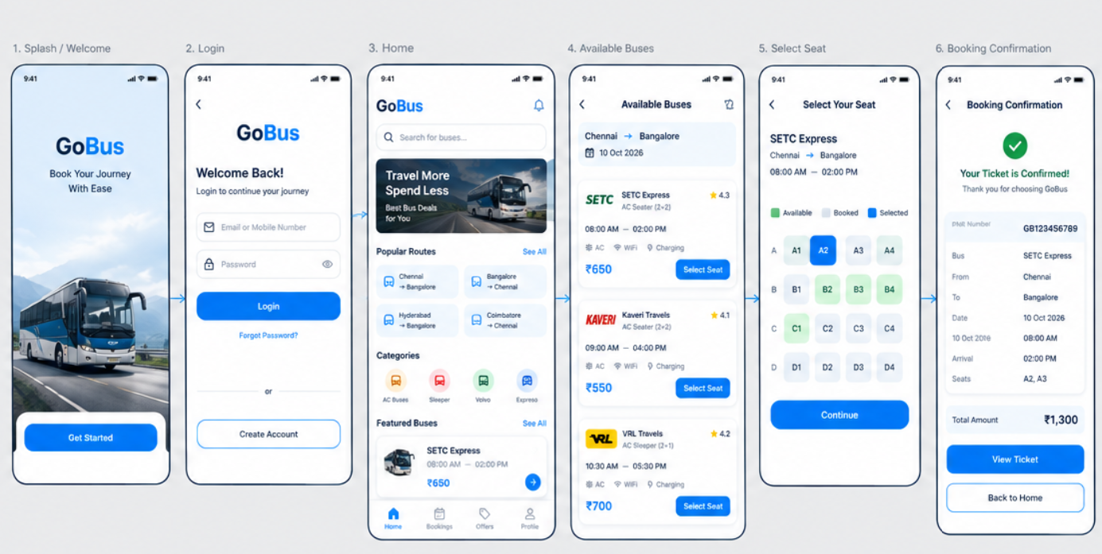
AIM
To design a simple Bus Ticket Booking System prototype using Figma, consisting of a Home Page and an Available Buses Page, with basic navigation between the two screens.
PROCEDURE
- Open Figma and create a new Design File.
- Select the Frame (F) tool and create a mobile phone frame.
- Design Screen 1 – Home Page.
- Add the title “Bus Ticket Booking”.
- Add input fields for:
  - From: Chennai
  - To: Bangalore
  - Date: 10 Oct 2026
- Add a “SEARCH BUSES” button.
- Create a second mobile frame for Screen 2 – Available Buses.
- Add the heading “Available Buses”.
- Add the route Chennai → Bangalore and date.
- Add bus details such as:
  - SETC Express – ₹650
  - Kaveri Travels – ₹550
  - VRL Travels – ₹700
- Add a “SELECT SEAT” button for each bus.
- Open the Prototype tab in Figma.
- Select the SEARCH BUSES button on Screen 1.
- Drag the prototype connection to Screen 2.
- Set the interaction to On Click → Navigate To.
- Click the Present/Play button to test the prototype.
- Verify that clicking SEARCH BUSES navigates from the Home Page to the Available Buses Page.
RESULT
A simple 2-screen Bus Ticket Booking System prototype was successfully designed and connected using Figma.

